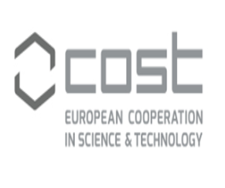

COST Info Day in Greece
DATE: March 27, 2018

VENUE: NCSR Demokritos, Athens Greece
Main Auditorium (congress center)
Part. Gregoriou E & 27, Neapoleos str., 15341, Ag.Paraskevi

Agenda

Moderator: Emmanuel STRATAKIS, member of Scientific Committee of COST

9:30 –10:00 Welcome addresses
George NOUNESIS, Director of the National Centre for Scientific Research “Demokritos”
Maria CHRISTOULA, acting Director, International Scientific & Technological Cooperation, GSRT

11:30 –12:00 Tips/guidelines on how to prepare a successful proposal for COST Open Call

10:00 –10:30 Promoting and Spreading Research Excellence: Perspectives from COST

- Sierd CLOETINGH, President of COST

10:30- 11:00 What are the COST Actions and how to participate

- Christer HALEN, Senior administrator Science Operations of COST

11:00 – 11:30 Coffee Break

- Christer HALEN, Senior administrator Science Operations of COST

12:00 –12:15 National participation in COST Actions

- Ioannis BARTZIS, Country representative for Greece

12:15 – 12:45 What is the added value and impact of participating in a COST Action- National Experiences
- Theodoros TRIANTIS: COST Action ES1105: Cyanobacterial blooms and toxins in water resources: Occurrence, impacts and management. (CYANOCOST)
- Katerina PASTRA: COST Action IC1307: The European Network on Integrating Vision and Language (iV&L Net): Combining Computer Vision and Language. Processing For Advanced Search, Retrieval, Annotation and Description of Visual Data

12:45 – 13:15 Q&A and discussion

13:15 – 14:15 Lunch

